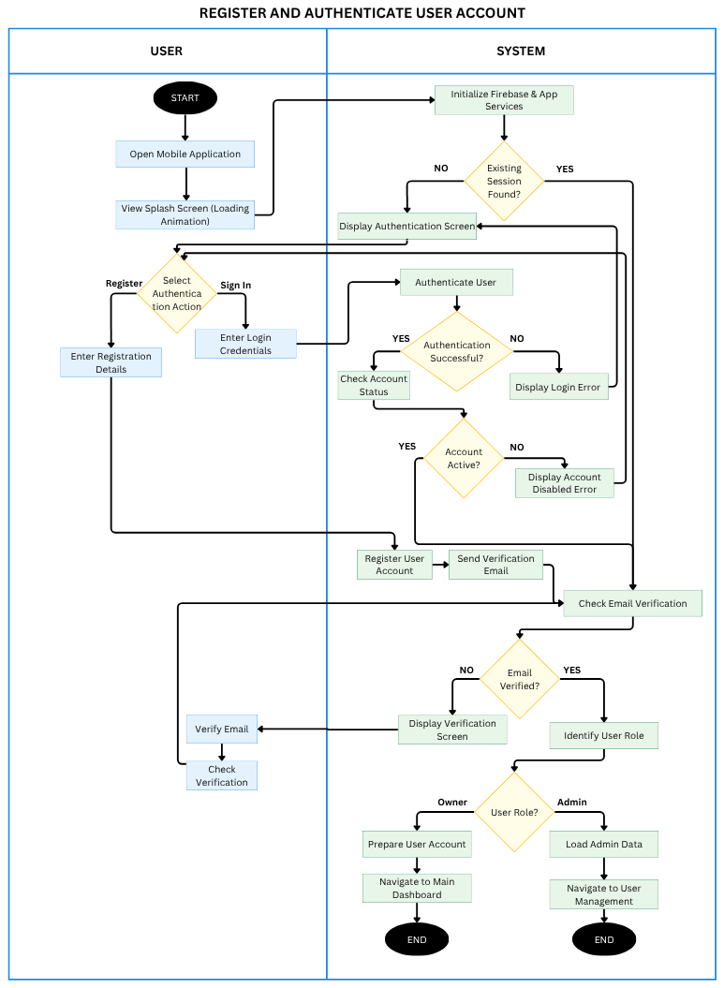
Figure 3.2. Activity Diagram for Registering and Authenticating a User Account
Figure 3.2 illustrates the activity flow for registering and authenticating a user account in CrayCare. When the application opens, it initializes the required services and checks for an existing session. A new user can register through email or Google sign-in, while an existing user provides valid credentials to sign in. The system validates the account, checks its status and verification requirements, and displays a relevant prompt if access cannot continue. After successful authentication, CrayCare identifies the user role and opens the appropriate owner or administrator interface.
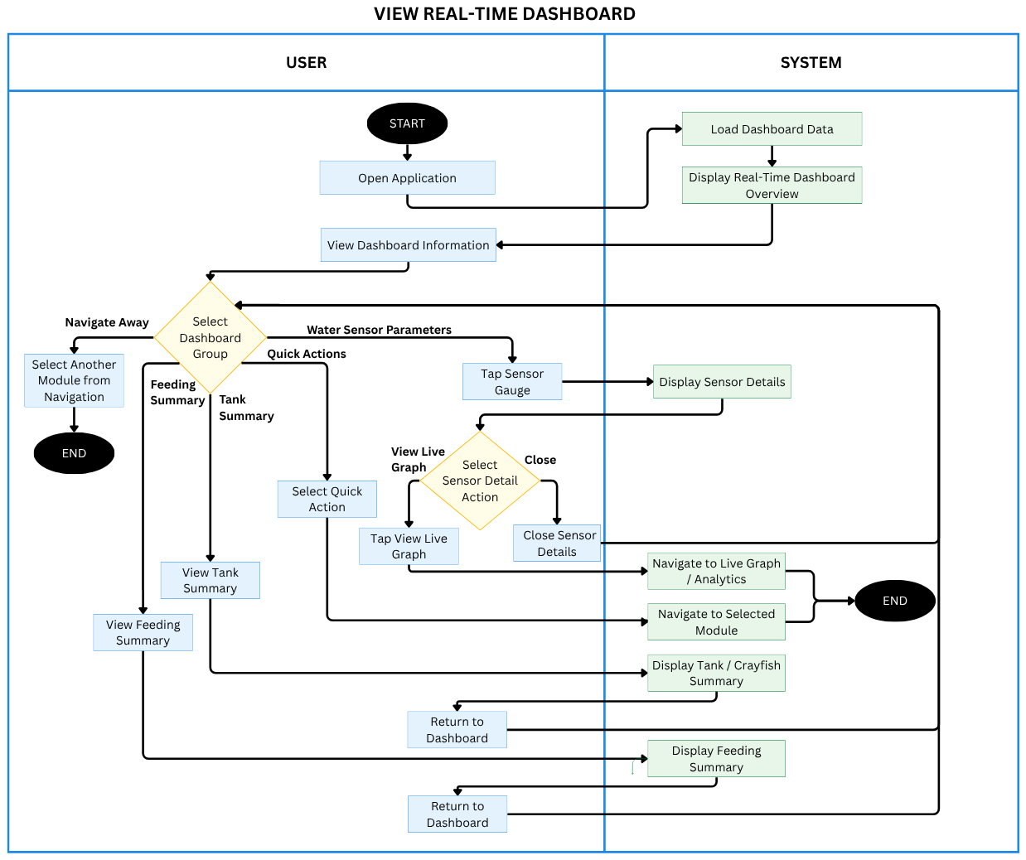
Figure 3.3. Activity Diagram for Viewing the Real-Time Dashboard
Figure 3.3 illustrates how a tank owner accesses the real-time dashboard. After the dashboard is opened, CrayCare retrieves the latest available sensor readings, device connectivity information, feeding progress, and tank summary data. The owner can review the water-condition cards and status indicators, open detailed sensor information or live charts, use available quick actions, or navigate to another feature. When the owner returns to the dashboard, the current information is shown again using the latest available data, including cached readings when the connection is temporarily unavailable.
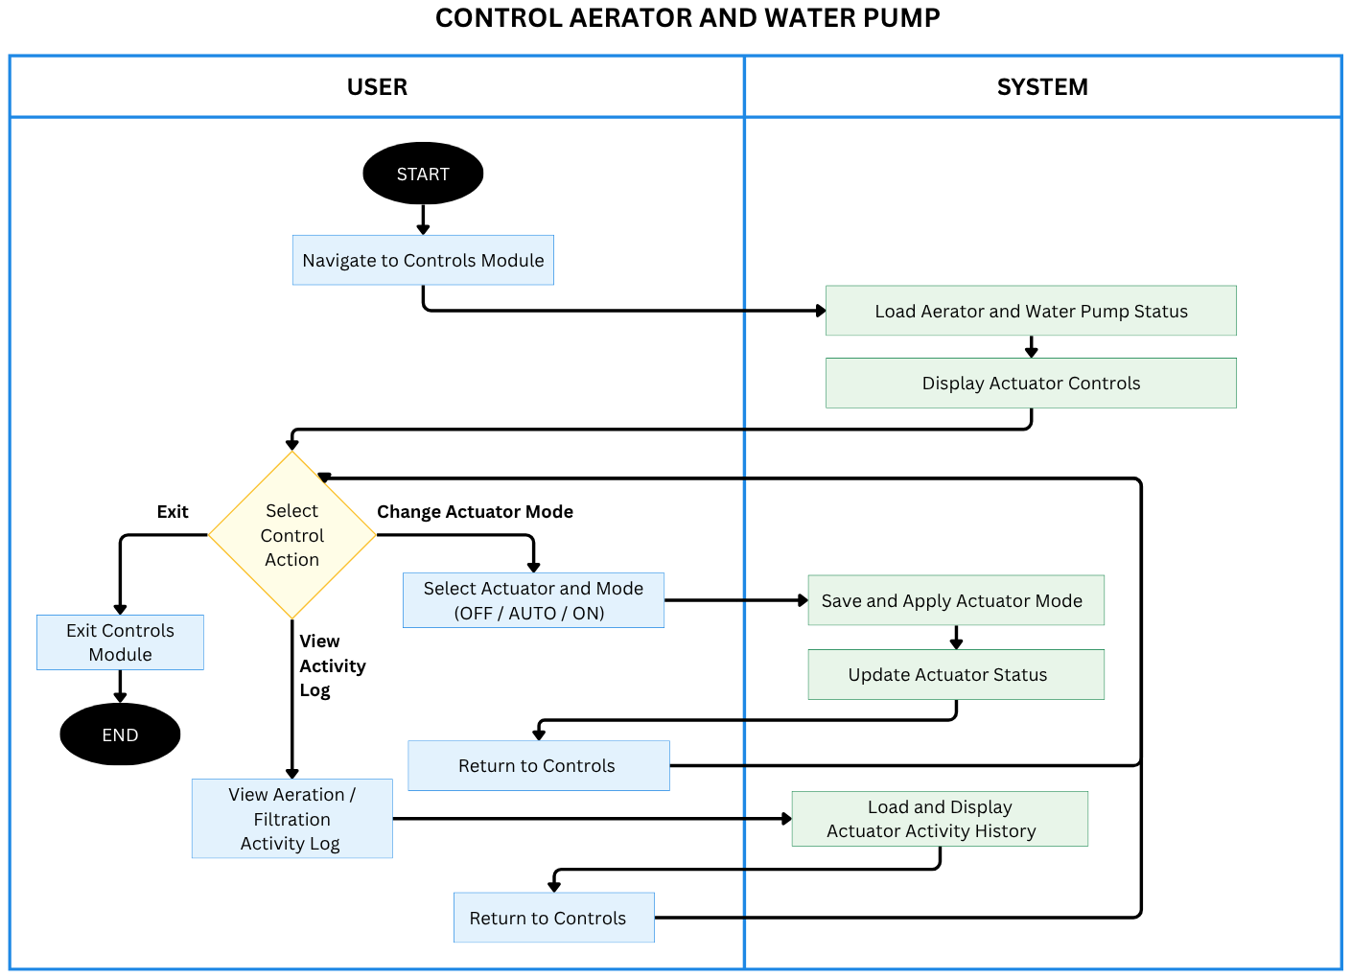
Figure 3.4. Activity Diagram for Controlling Aerators and the Water Pump
Figure 3.4 illustrates how the tank owner controls the aerator and water pump. The owner opens Controls, selects a control action, and either changes an actuator mode to OFF, AUTO, or ON, views the aeration or filtration activity log, or exits the module. For a mode change, CrayCare saves and applies the selection, updates the actuator status, and returns to Controls. When the activity log is selected, the system loads and displays actuator activity history before returning to the controls screen.
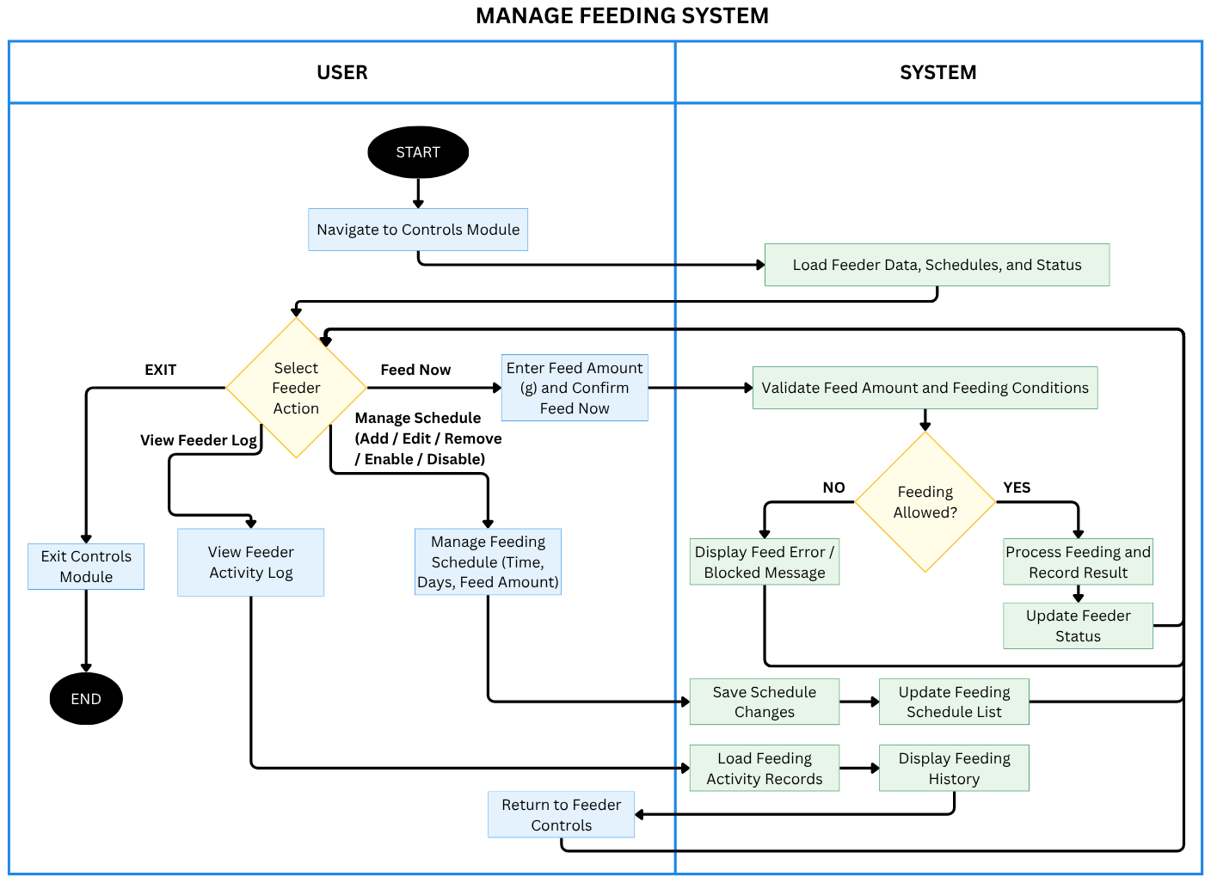
Figure 3.5. Activity Diagram for Managing the Feeding System
Figure 3.5 illustrates how the tank owner manages automated and manual feeding. The owner may create, edit, enable, disable, or remove a recurring feeding schedule by providing its days, time, and feed amount. Feed amounts must be whole numbers from 1 to 200 g. For immediate feeding, the owner selects Feed Now and enters an amount. CrayCare checks sensor freshness, feed-level safety, and schedule timing before sending the command; it may require confirmation near a scheduled feeding or block Feed Now when a schedule is due. The same water-quality override preference applies to manual and scheduled feeding, but it does not bypass stale sensor data, turbidity sensor-in-air detection, or critical feed-level safety. The feeder returns its execution status, and the application updates feeding progress and the activity log so the owner can review completed, skipped, failed, and upcoming feeding events.
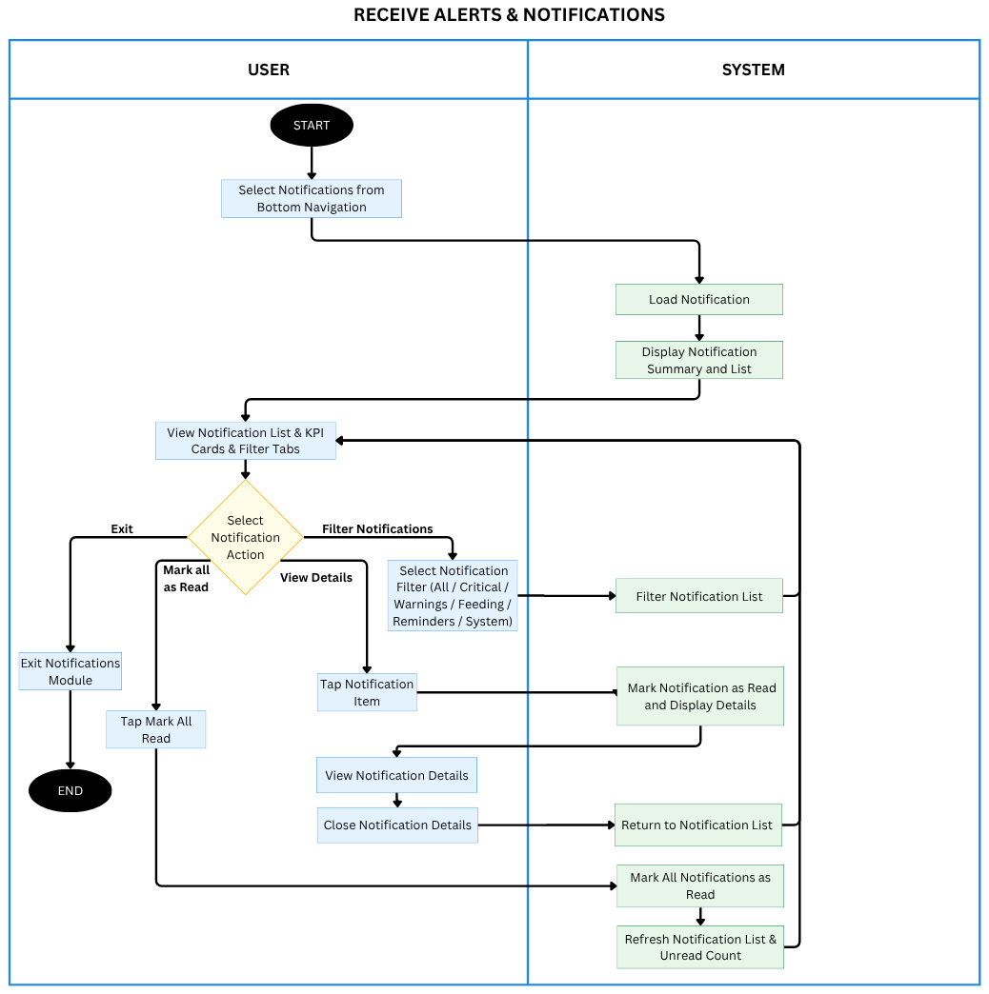
Figure 3.6. Activity Diagram for Receiving Alerts and Notifications
Figure 3.6 shows how the tank owner views and manages notifications. The owner opens Notifications, and CrayCare loads and displays the notification summary and list. The owner may filter the list by All, Critical, Warnings, Feeding, Reminders, or System; open a notification to mark it as read and view its details; or mark all notifications as read. CrayCare refreshes the list and unread count after read-status changes. The owner can exit the Notifications module at any time.
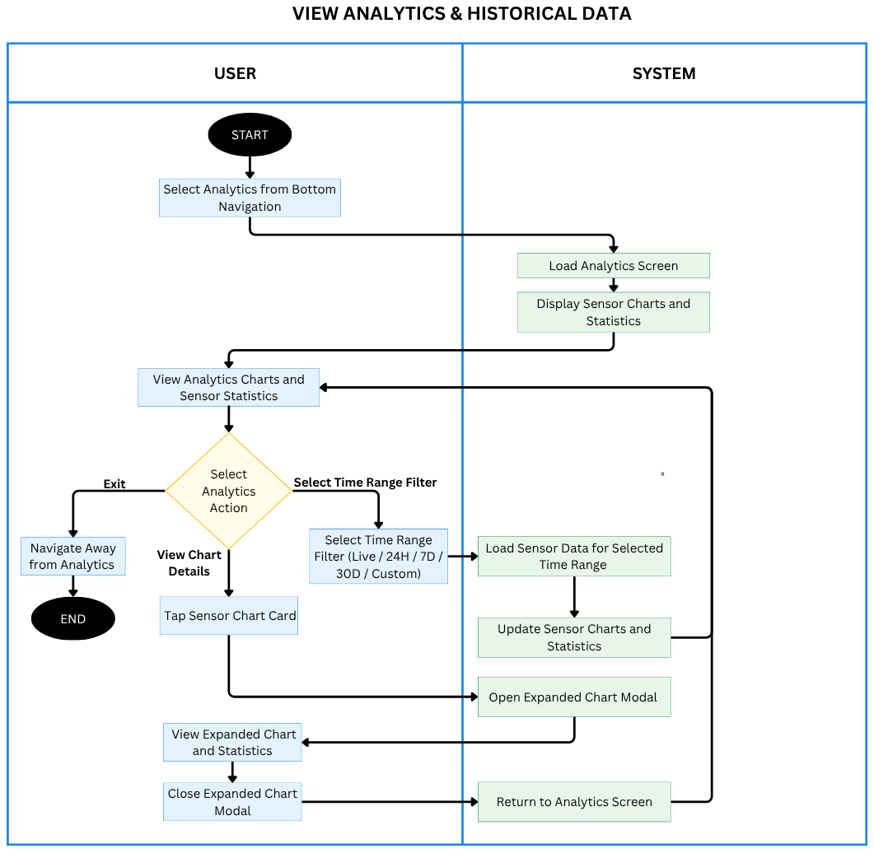
Figure 3.7. Activity Diagram for Viewing Analytics and Historical Data
Figure 3.7 illustrates how the tank owner views analytics and historical sensor data. CrayCare loads the Analytics screen and displays sensor charts and statistics. The owner can select a time range (Live, 24H, 7D, 30D, or Custom), and the system loads data for that range and updates the charts and statistics. The owner may tap a sensor chart card to open an expanded chart, review its statistics, close the chart, and return to Analytics, or navigate away from the module.
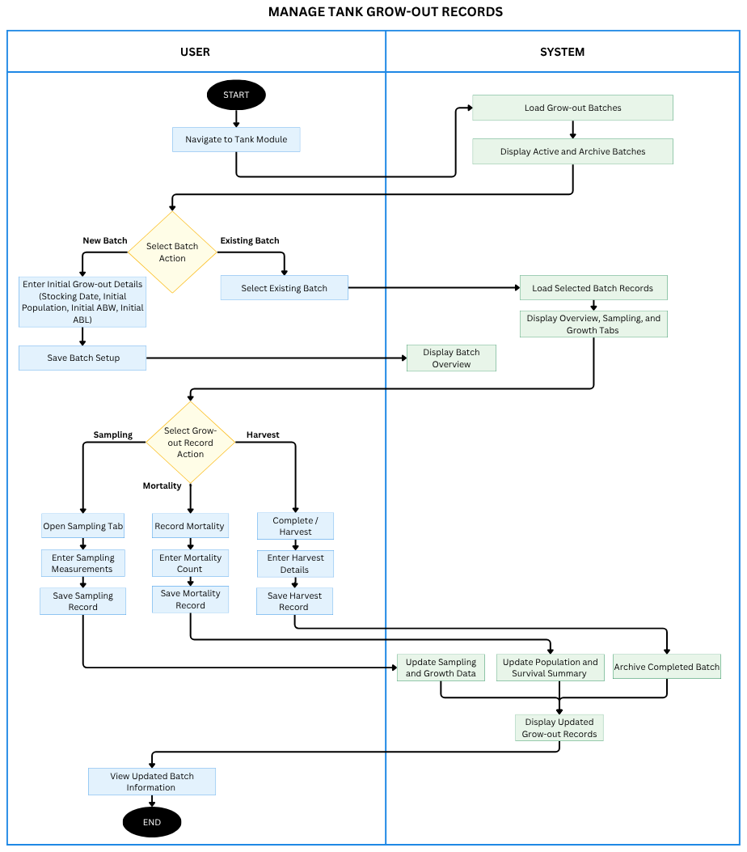
Figure 3.8. Activity Diagram for Managing Tank Grow-Out Records
Figure 3.8 illustrates the activity flow for managing tank grow-out records. The tank owner initializes a batch by entering the tank and baseline stocking information, including a baseline sample size and the individual weight and length of each crayfish in that sample. Later sampling records use the same sample size and save each crayfish’s individual measurements; the latest weekly record can be corrected without changing its sample size. CrayCare validates the submitted values, saves the record, and updates the related population, growth, survival, and culture-day information. The owner can review the batch history and updated summary after each record is saved. When a batch is completed, the owner may record the harvest and close the batch while retaining its historical records for later review and reporting.
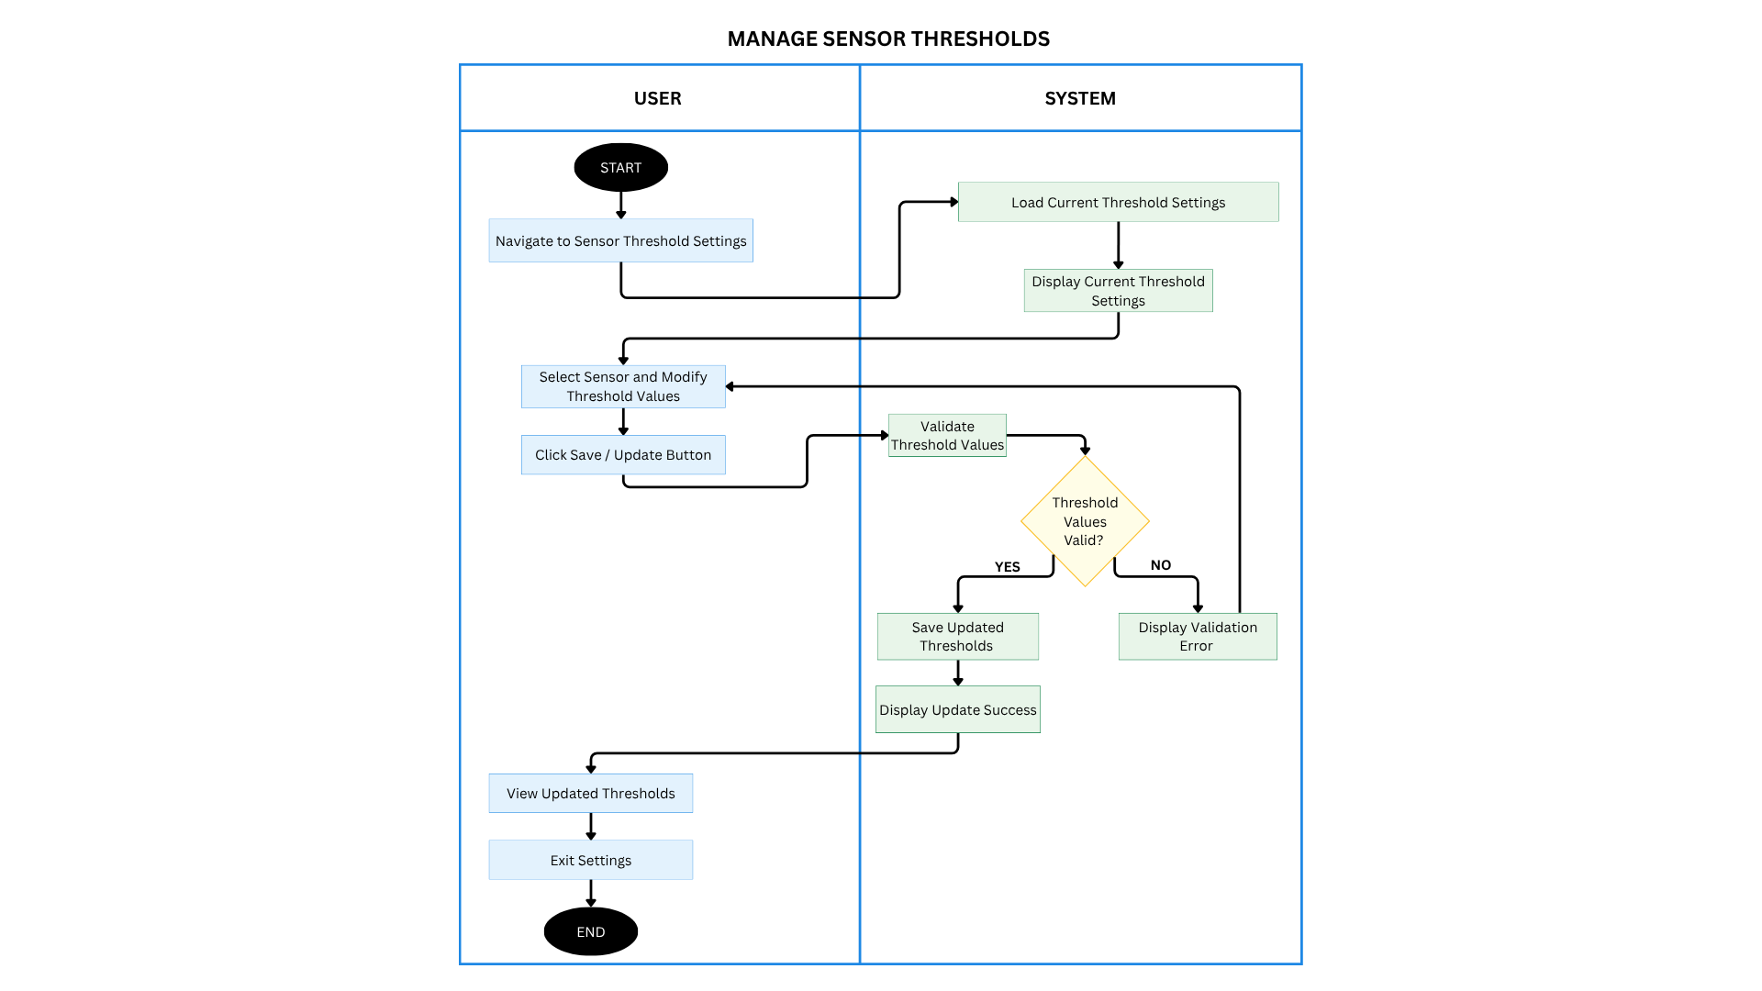
Figure 3.9. Activity Diagram for Managing Sensor Thresholds
Figure 3.9 illustrates how the tank owner manages sensor thresholds in Settings. The owner opens the sensor-threshold settings, reviews the current values, selects a sensor, and edits its thresholds. CrayCare validates the entries; valid values are saved and the updated settings are displayed, while invalid values produce a validation message so they can be corrected. Thresholds are configured according to sensor type, covering water-quality parameters, water level, and feed level.
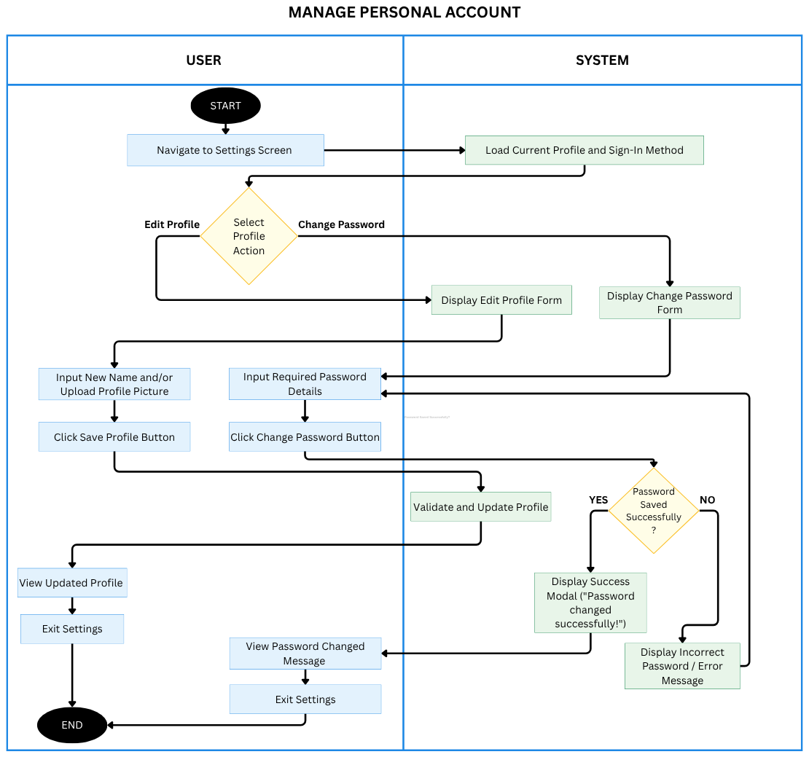
Figure 3.10. Activity Diagram for Managing a Personal Account
Figure 3.10 illustrates how the tank owner manages a personal account. From Settings, the owner can choose to edit the profile or change the password. For profile editing, the owner enters a new name and/or uploads a profile picture, then saves; CrayCare validates and updates the profile before displaying the updated information. For a password change, the owner enters the required password details and submits them. CrayCare displays a success message if the password is changed, or an error message if it is not, then allows the owner to exit Settings.
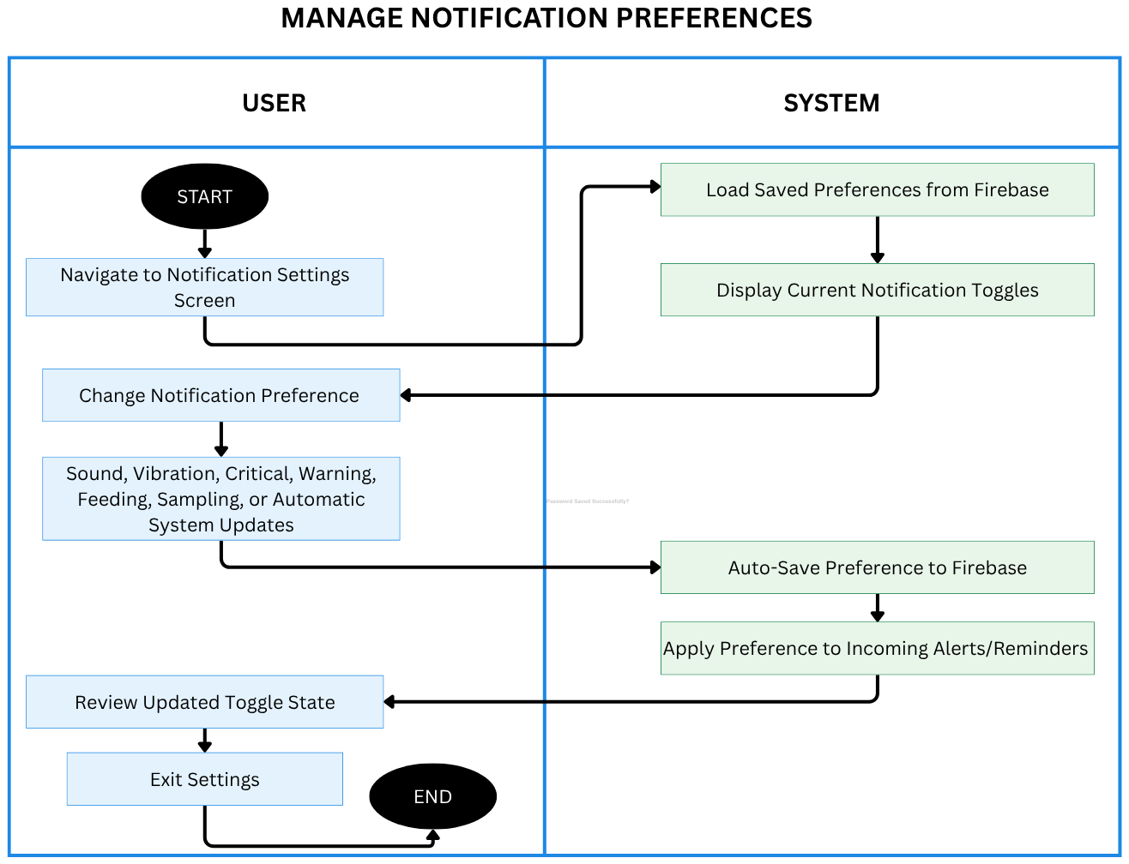
Figure 3.11. Activity Diagram for Managing Notification Preferences
Figure 3.11 shows how the tank owner manages notification preferences. CrayCare loads the saved preferences from Firebase and displays the current toggles. The owner can change sound, vibration, critical, warning, feeding, sampling, or automatic system-update preferences. The system automatically saves each change to Firebase and applies the selected preferences to incoming alerts and reminders, then displays the updated toggle state.
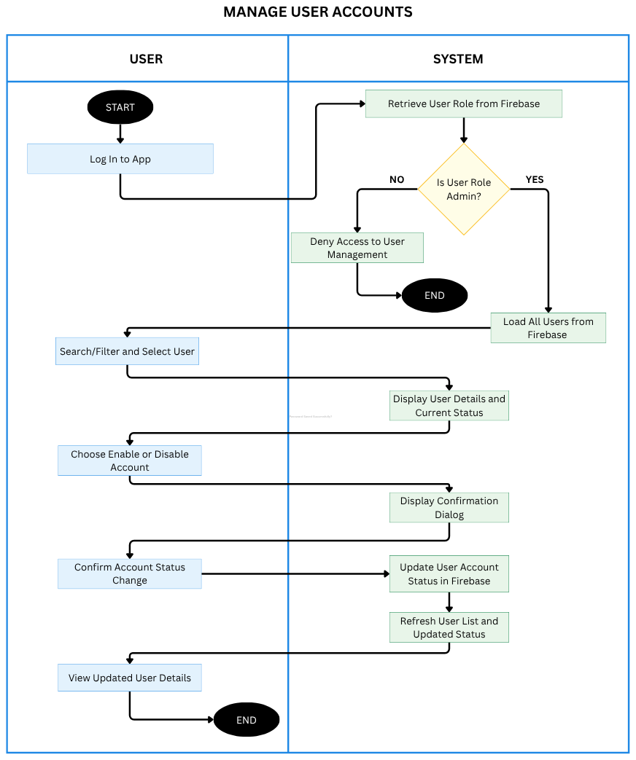
Figure 3.12. Activity Diagram for Managing User Accounts
Figure 3.12 illustrates the activity flow for System Admin management of user accounts. After signing in, the system verifies that the user has administrator access before loading the owner-account list. The administrator can search or filter the list, select an account, and review its current status. When an enable or disable action is selected, CrayCare requests confirmation and updates the account status only after confirmation is provided. The refreshed user list displays the resulting status, while unauthorized users are prevented from entering the management function.
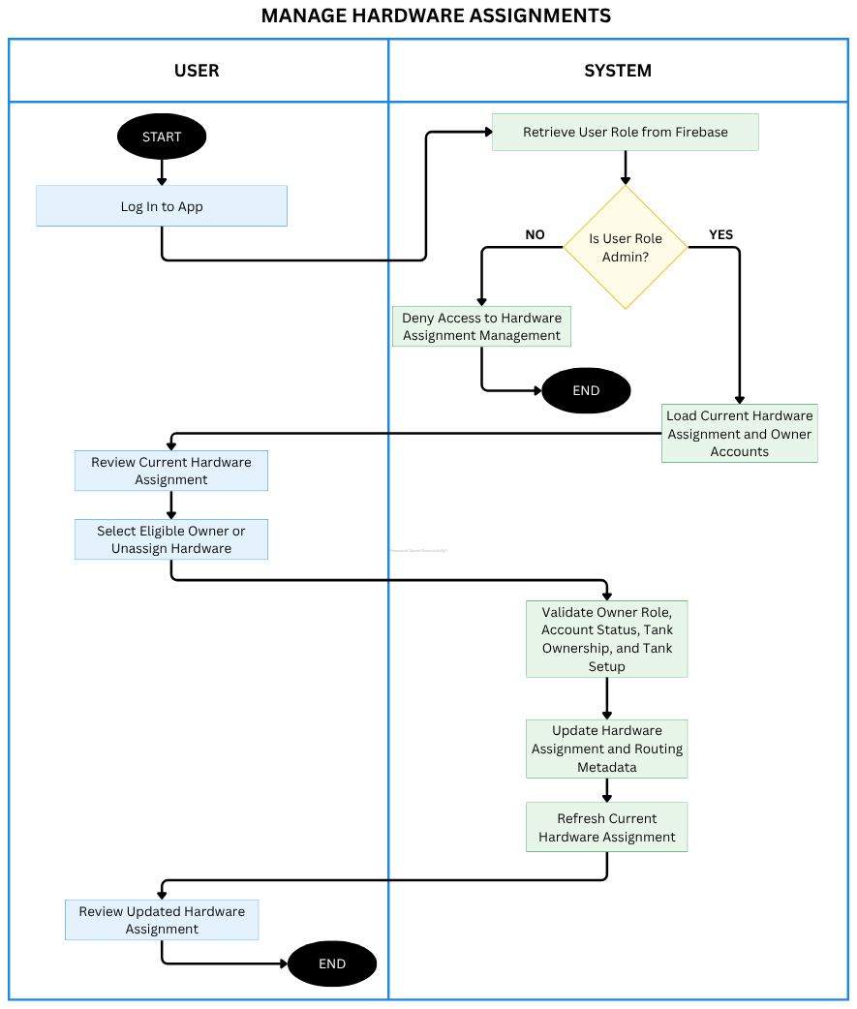
Figure 3.13. Activity Diagram for Managing Hardware Assignments
Figure 3.13 illustrates how the System Admin manages hardware assignments. The administrator opens the assignment feature and the system loads the current device assignment together with eligible owner accounts. The administrator can select an owner for the active hardware system or remove the current assignment. CrayCare validates the selected account and assignment conditions before saving the change. Once updated, the assignment status is refreshed and displayed to the administrator. This process ensures that tank operations and IoT data are associated with the intended owner account.
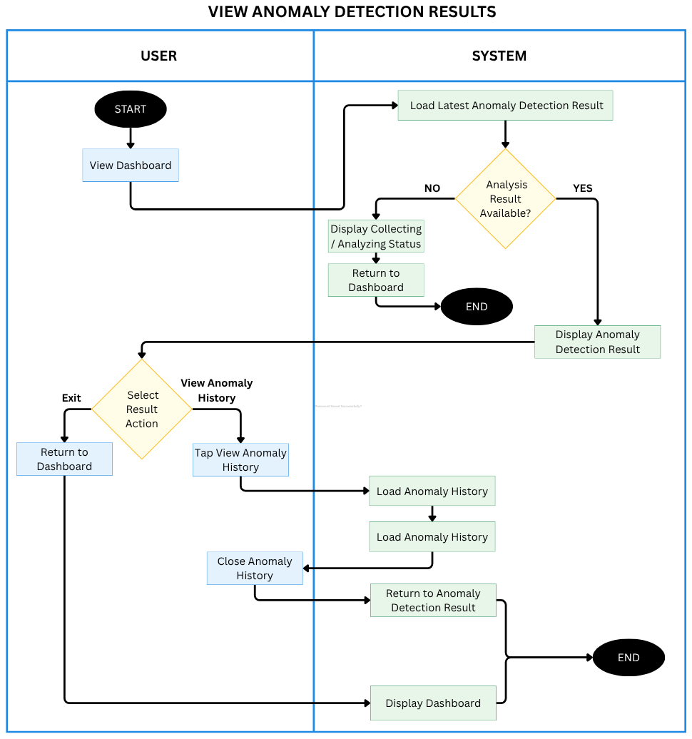
Figure 3.14. Activity Diagram for Viewing Anomaly Detection Results
Figure 3.14 illustrates how the tank owner views water-quality anomaly detection results from the dashboard. CrayCare loads the latest analysis result. If no result is available, it displays a collecting or analyzing status and indicates that 12 continuous sensor readings are needed before the first result is available. If a result is available, the owner can review its status, anomaly score, contributing sensor readings, insight, and recommendation; open anomaly history; and return to the result or dashboard.
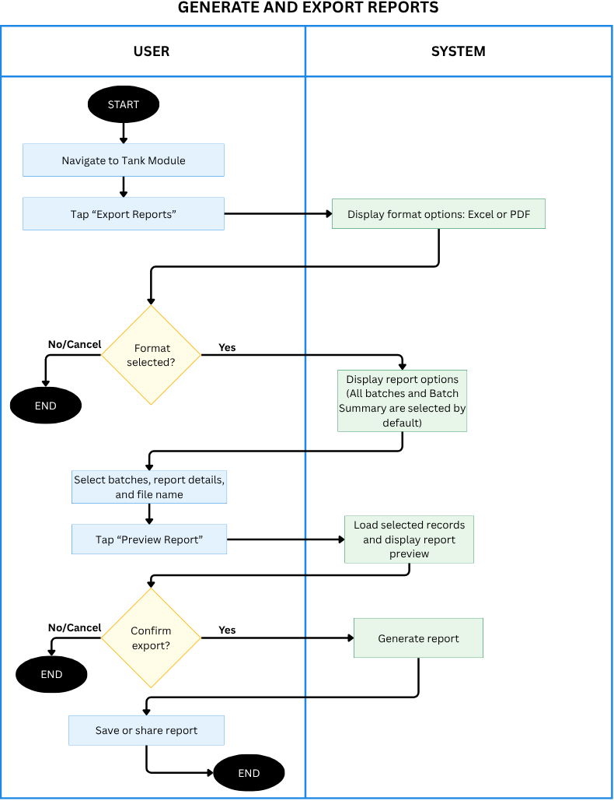

Figure 3.15. Activity Diagram for Generating and Exporting Reports

Figure 3.15 illustrates how the tank owner exports a grow-out report. From the Tank module, the owner taps Export Reports and chooses Excel or PDF. CrayCare displays report options, with all batches, the batch summary, and detailed records selected by default; individual measurements are included by default when saved measurement data is available. The owner can select batches, choose report details, enter a file name, and preview the report. When individual measurements are included, the report groups them by sampling week and date and lists each crayfish’s number, weight, and length. After previewing, the owner confirms or cancels the export. Confirmation generates the report and opens the device save/share options; cancellation ends the process.

